React JS

Which of the following is true about React?

A. React is a JavaScript library for building user interfaces.

B. React is used to build single page applications.

C. React allows us to create reusable UI components.

D. All of the above

Answer:(c)

2) A class is a type of function, but instead of using the keyword function to initiate it, we use the keyword?

A. constructor

B. class

C. object

D. dataObject

    Answer:(B)

3)  JSX allows us to write HTML elements in JavaScript and place them in the DOM without any?

A. createElement

B. appendChild

C. getElementById

D. Both A and B

 Answer:(D)

4) Does React creates a VIRTUAL DOM in memory.

A. TRUE

B. FALSE

C. Can be true or false

D. Can not say

Answer:(A)

5)  With JSX you can write expressions inside?

A. ()

B. []

C. " "

D. {}

 Answer:(D)

6) What is ReactJS?

A.  Server side Framework

B.  User-interface framework

C. Database

D.  A Library for building interaction interfaces

 Answer:(D)

7)  Props are __________ into other components

A) Injected

B) Methods

C) Both A & B

D) All of the above

  Answer:(B)

8) ReactJS uses _____ to increase performance

A) Virtual DOM

B) Original DOM

C) Both of above

D) None of above

 Answer:(A)

9) State in react is________

A) A permanent storage

B) Internal storage of the component

C) Both of above

D) None of above

 Answer:(B)

10) props in react can________

A) Be changed inside the component

B) Not be changed in the component

C) Be changed in side other component

D) None of above

  Answer:(B)

11) In ReactJS, props can be used to pass

A) Properties to the component

B) Event handler to component

C) Both of above

D) None of above

 Answer:(C)

12) As soon as the state of react component is changed, component will

A) Does nothing , you have to call render method to render the component again

B) re-renders the component

C) be created again from scratch

D) None of above

Answer:(B)

13) AnHowAn many elements does a react component return?

A) 1

B) 0

C) Multiple elements with one root element

D) None of the above

 Answer:(D)

14) Reactjs is a _________

A) server side framework

B) user interface framework

C) Library for building interaction interfaces

D) bundled jars

 Answer:(C)

15) What are two ways data gets handled in react?

A) state & props

B) services & components

C) state & services

D) state & component

 Answer:(A)

Test 1:  
Create a Calculator using state and props. Please ref image below you UI

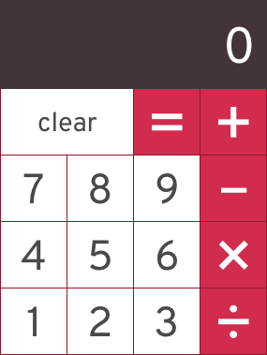

Test 2 :

Create a countdown timer ref to the below image for UI.